Graph Theory and Data Science
Graph theory began all the way back to 1736 in the Prussian city of Königsberg . Back then the city was centred around two islands within the Pregel river, and these were connected with the mainland by seven distinct bridges. As the story goes, there arose a contest among local bridge lovers to see who could devise the optimal route to traverse each bridge across the Pregel while only crossing an individual bridge once. Thereby seeing all the bridges in their full glory in the minimum amount of time.
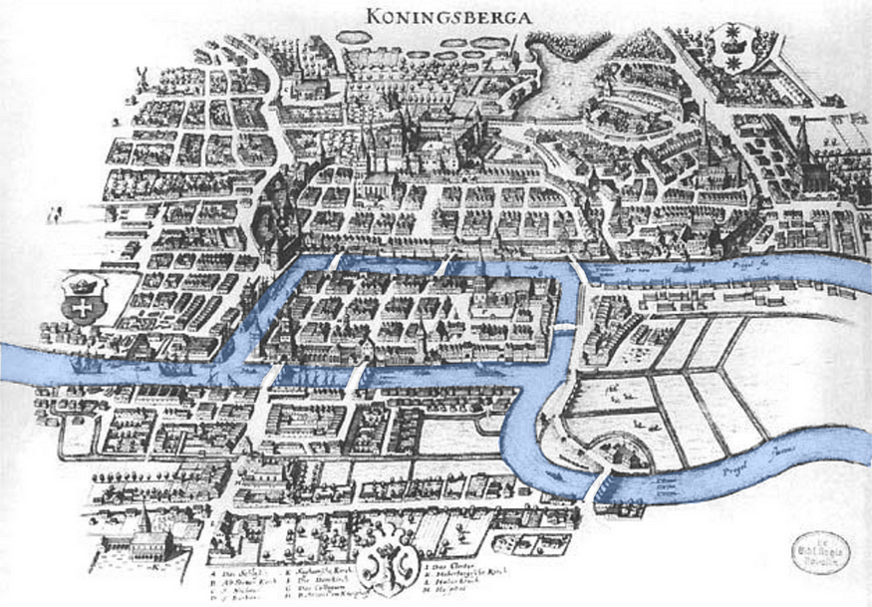
While very simple to understand this problem proved to be very difficult to solve. Word of this puzzle spread until it caught the attention of mathematician Leonhard Euler. He was able to prove that the problem actually had no valid solution and in doing so laid the foundations of Graph Theory.
The Königsberg bridge problem, also known as the Seven Bridges of Königsberg, is a famous mathematical problem that dates back to the 18th century. The problem is named after the city of Königsberg (now Kaliningrad, Russia), which was divided by the Pregel River and included two large islands connected by seven bridges.
The problem was to determine if it was possible to walk through the city of Königsberg, crossing each of the seven bridges exactly once, and returning to the starting point. This problem laid the foundation for the development of graph theory, which is a branch of mathematics that deals with the study of graphs and their properties.
To represent the Königsberg bridge problem using graph theory, we can create a graph where each landmass is represented by a node (vertex) and each bridge is represented by an edge connecting the corresponding nodes. The goal is to find a path that traverses all edges exactly once.
To easier understand his solution, we’ll cover some Graph Theory terminology.
- A Graph G(V, E) is a data structure that is defined by a set of Vertices (V) and and a set of Edges (E).
- Vertex (v) or node is an indivisible point, represented by the lettered components on the example graph below
- An Edge (vu) connects vertex v and vertex u together.
- The Degree d(v) of vertex v, is the count of edges connected to it.
- The Parity of a vertex refers to whether d(v) is even or odd.
- An Eulerian Path is a path in a finite graph that visits every edge exactly once (allowing for revisiting vertices).

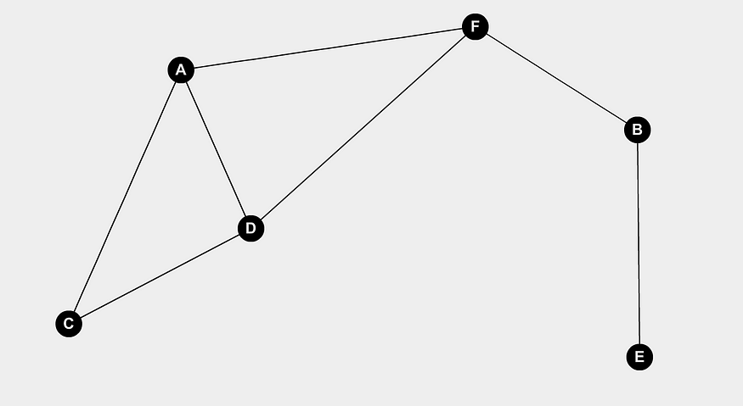
Fig 2: Example Graph with 6 Vertices and 7 Edges
Now back to Prussia! Let’s convert the map of Königsberg and its bridges into a graph using what we’ve learned. In this graph-representation each landmass will become a vertex, and each bridge an edge.

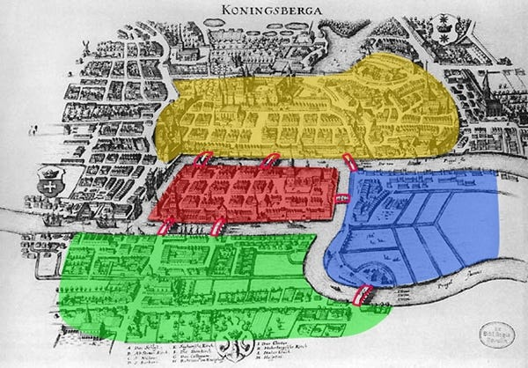
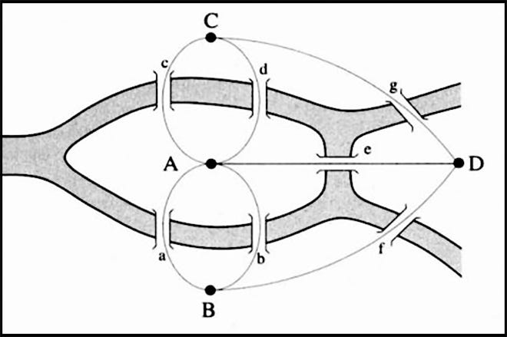
Fig 3. Mapping Königsberg onto a Graph
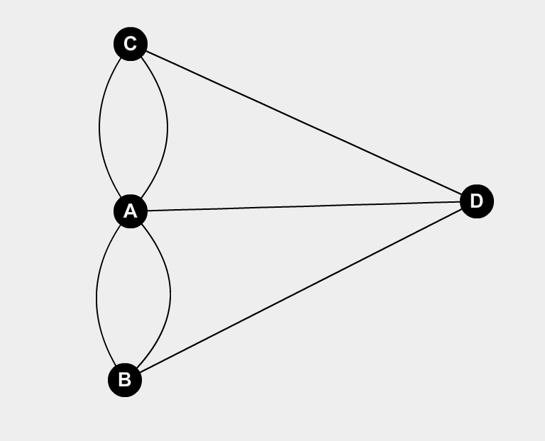
Fig 4. Graph of Königsberg Bridges
Now lets try an Eulerian Path on this graph in the following order:
- A → B → D
- D → A → C
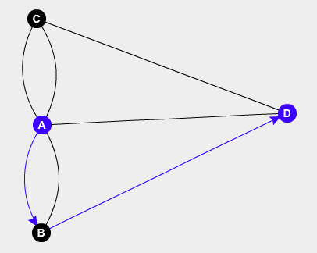
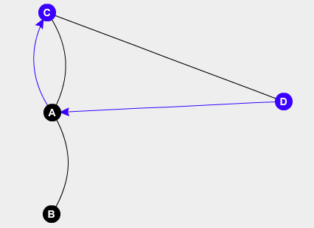
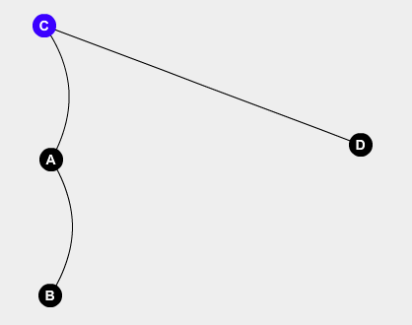
Fig 5. Eulerian walk attempt
I think that after we have traversed to vertex C is easy to see that our path cannot be completed as we will end at either B or D.
Working through example walks like the one above Euler realized the heart of the problem concerned the parity of each vertex. That a traveller mid-walk would always need an entrance and exit edge from each vertex in order to continue their walk. So even parity is always needed in order to continue the walk.
Therefor for a traveler attempting an Eulerian walk along graph G the following must be true for it to be completed:
- G must be connected
- G must have exactly zero or two vertices of odd degree
Additionally if G has two vertices of odd degree then the walk must begin on one and end on the other odd vertex.
The field that grew out of this initial problem is only increasingly relevant in our highly connected world. Graph Theory can be used to represent and analyze a wide variety of network information and has numerous modern applications within Data Science.
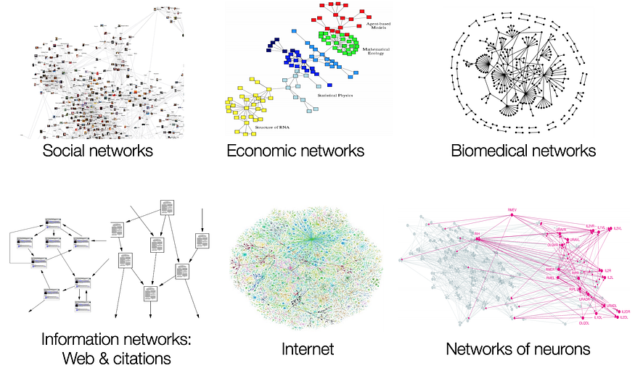
Fig 6. Variety of Graph Representations of Networks
It has also been been fundamental to the development of numerous foundational algorithms from Google Page Rank to Netflix Content Recommendation.
Graph theory is the study of structures that have pairwise relations.
A graph consists of vertices, sometimes called nodes or points, that are connected by edges, which are sometimes referred to as lines or links. Typically edges are easiest to define as a set of the 2 vertices they connect.
Definition: A graph G=(V,E) is a set of vertices V and edges E that are made up of pairs of vertices.
In the graph below, the vertices are V={A, B, C, D}, and the edges are written as the pairs E={(A, B), (D, A), (D, C), (C, B)}.
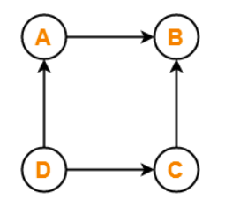
An important note is that the above graph is a directed graph. We can tell it is a directed graph because the edges have arrows on them, indicating movement from one vertex, at the tail of the arrow, to the vertex at the head of the arrow. This means that the edges, which are written as pairs of vertices, must have a specific order to them. In the case above, the starting vertex is always written first, so (D, A) is an edge in the graph, but (A, D) is not.
When the edges are just lines with no arrows, the graph is undirected, which means the edges can be written in any order.

Types of Graphs

Complete Graph
A complete graph is a graph where every node is connected to every other node. In the figure below, there are 12 nodes, each of which has an edge connecting it to every other vertex. In a complete graph with n vertices, which is denoted Kₙ, there are exactly n choose 2 edges. Typically, a complete graph is undirected.
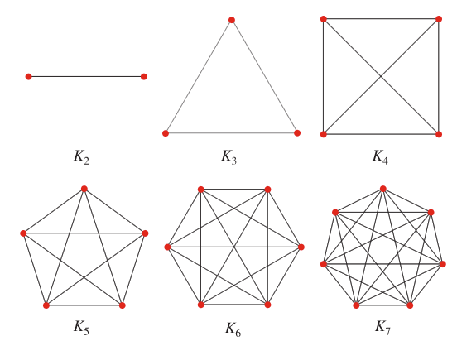
6 Complete Graphs
Complete graphs arise in a number of settings and often are useful in understanding more complex problems in graph theory. Understanding where a complete graph can be found gives insight into how connected a graph is.

Bipartite Graph
A bipartite graph has 2 sets of vertices. When the 2 sets are of size m and n, the complete bipartite graph is denoted kₙ,ₘ.
In the figure below, these sets are shown as yellow and blue. A graph is bipartite if there exist no 2 vertices in the same set that are joined in an edge. A graph is a complete bipartite graph if every vertex in one set is connected by an edge to every vertex in the opposite set, as is the case in the figure below.
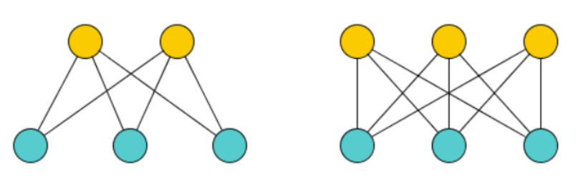
Bipartite Graph
Bipartite graphs are useful for thinking about matching problems. You can think of each of the 2 sets as a group that is to be matched with the opposite group. A classic example is using bipartite graphs to model who is interested in dating who, where people only data others from the opposite group.

Planar Graphs
A planar graph is any graph that you can draw on a flat piece of paper without crossing 2 edges over each other. While this doesn’t seem like the most complicated problem, identifying when a graph is planar or can be drawn in a planar form is an interesting problem.
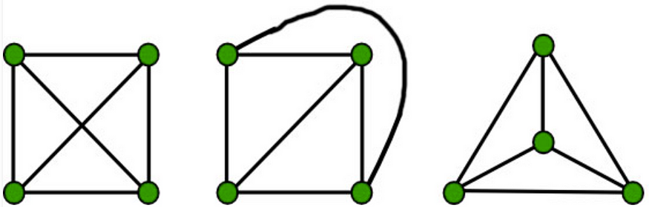
An example of redrawing a graph to uncross edges.
On the left this graph doesn’t appear planar because 2 edges cross. In the middle graph, the diagonal edge has been moved to go “around the graph” so that no 2 edges cross, making it planar. Finally, the graph all the way on the right has some of the vertices shifted so that it looks a little cleaner.
It is not immediately apparent that the graphs on the left and right have the same structure of vertices and edges, but following the shift from the left to the right can help. This problem of identifying which graphs have similar structure, which graphs are isomorphic, is a fundamental problem in graph theory and is in the computational class of NP problems.
While it isn’t always easy to identify which graphs are similar, identifying which graphs are planar is reasonably well understood with the following theorem.
Wagner’s Theorem: A graph G is planar if and only if the complete graph K₅ or the complete bipartite graph K₃,₃ can’t be obtained from G by deleting edges or vertices or contracting edges.
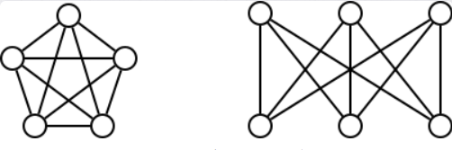
K₅ or K₃,₃
Contracting vertices is what happens when an edge is deleted and the 2 nodes at the end of the edge are joined. I won’t give a proof of Wagner’s Theorem here, but it is a very powerful idea and important to understand.
This is only the tip of the iceberg for graph theory. There are a lot of great applications, ideas, and problems to think about. Graph colouring, disease transmission in a network, and the internet are all fundamentally based on the ideas behind graph theory.

Graph Theory, in essence, is the study of properties and applications of graphs or networks. As I mentioned above, this is a huge topic and the goal of this series is to gain an understanding of how to apply graph theory to solve real world problems. If we look out the premise we live, we could see a number of problems popping out which in turn could be modeled as graphs. For example, choosing a dress combination out of all given categories could be thought of as a perfect scenario.
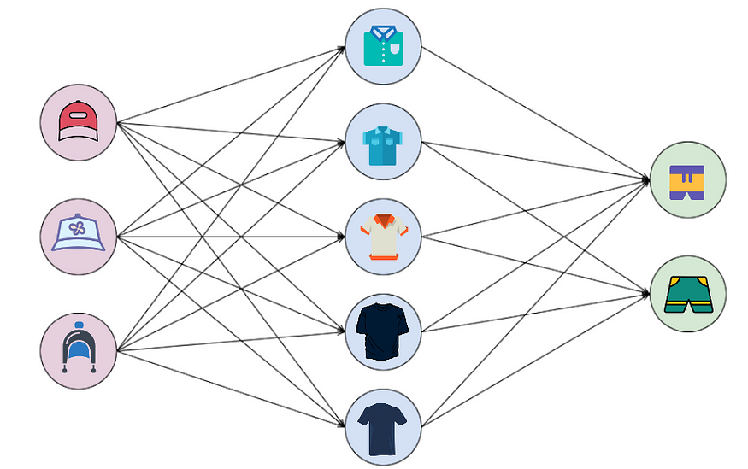
If we choose each item from each category like one from caps and another one from T-shirts and so on, we would end up in n possible options. The constraint we have here is, each category has only a limited number of resources. Still, we would have a decent amount of combinations. In this case, we could use graphs to showcase different categories of clothing in each node and relationships among them via edges. I hope the idea behind nodes and edges is known to everyone. If no, nodes could be thought as each item each category, for example, the red cap is a node and the green trouser is also a node, as well. The relationship among different nodes could be depicted using edges i.e. from red cap to blue t-shirt.
Another canonical example of a graph is a social network of friends. Visualizing data onto graphs allows us to generate and answer different interesting questions about the data.
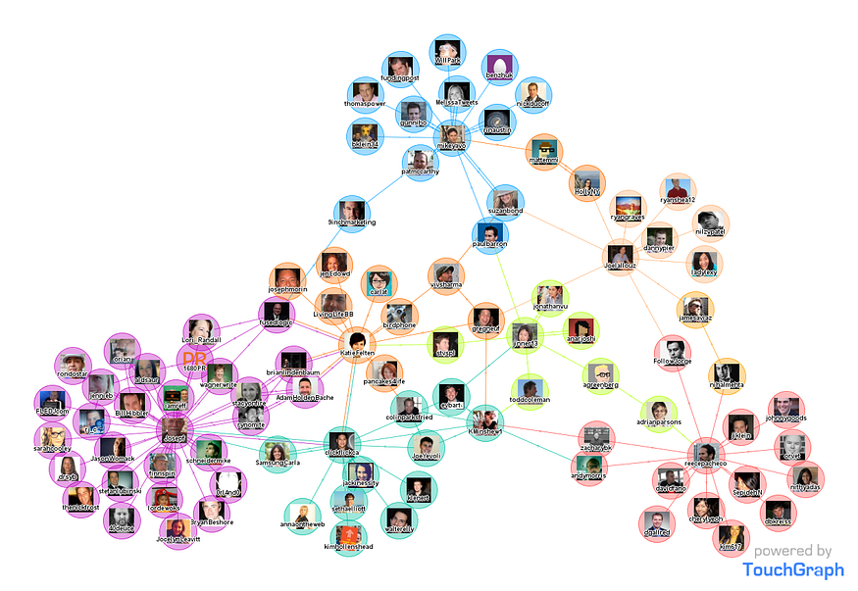
In the case of a social network, we could ask questions like how many friends does John have or how many mutual friends are there between Cathy and Milan.

Types of Graphs
There are different types of graph representations available and we have to make sure that we understand the kind of graph we are working with when programmatically solving a problem which includes graphs.
- Undirected Graphs
As the name shows, there won’t be any specified directions between nodes. So an edge from node A to B would be identical to the edge from B to A.
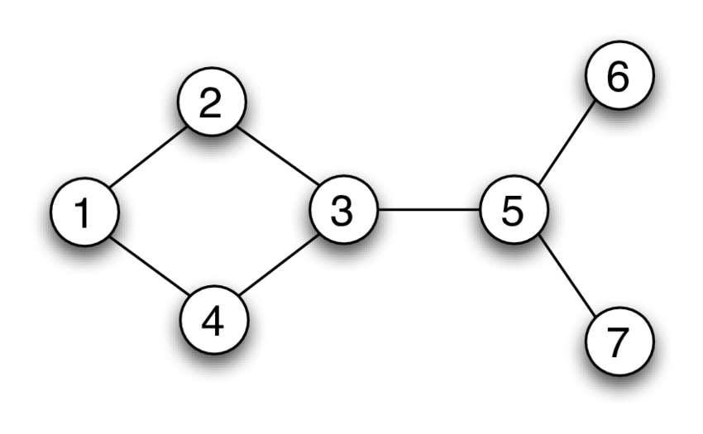In the above graph, each node could represent different cities and the edges show the bidirectional roads.
- Directed Graphs (DiGraphs)
Unlike undirected graphs, directed graphs have orientation or direction among different nodes. That means if you have an edge from node A to B, you can move only from A to B.
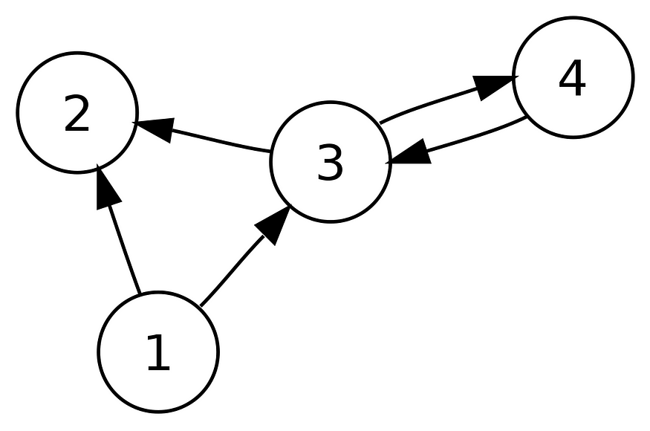
Like the previous example, if we consider nodes as cities, we have a direction from city 1 to 2. That means, you can drive from city 1 to 2 but not back to city 1, because there is no direction back to city 1 from 2. But if we closely examine the graph, we can see cities with bi-direction. For example cities 3 and 4 have directions to both sides.
- Weighted Graphs
Many graphs can have edges contain a weight associated to represent a real world implication such as cost, distance, quantity etc …
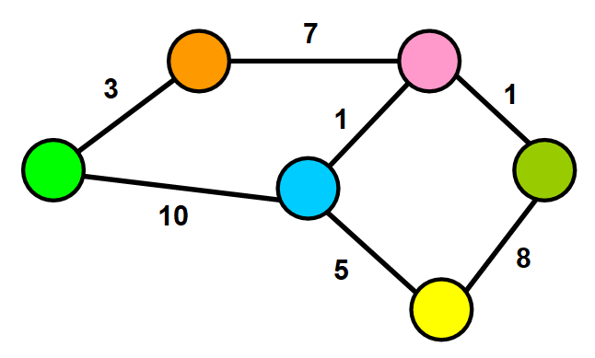
Weighted graphs could be either directed or undirected graph. The one we have in this example is an undirected weighted graph. The cost or distance from node green to orange and vice versa is 3. We could represent this relationship as a triplet like (u, v, w) which shows from where the edge is coming in, where it goes and cost or distance between the two nodes. Like our previous example, if you want to travel between two cities say city green and orange, we would have to pay off a cost of 3$ or in other terms, we would have to drive 3 miles. These metrics are self-defined and could be changed according to the situations. For a more elaborated example, consider you have to travel to city pink from green. If you look at the city graph, we can’t find any direct roads or edges between the two cities. So what we can do is to travel via another city. The most promising routes would be starting from green to pink via orange and blue. If the weights are costs between cities, we would have to spend 11$ to travel via blue to reach pink but if we take the other route via orange, we would only have to pay 10$ for the trip.

Special Graphs
Apart from the above divisions, we have another set of graphs called special graphs.
- Tree
The most important type of special graphs is a tree. It’s an undirected graph with no cycles. Equivalently, it has N nodes and N — 1 edges.
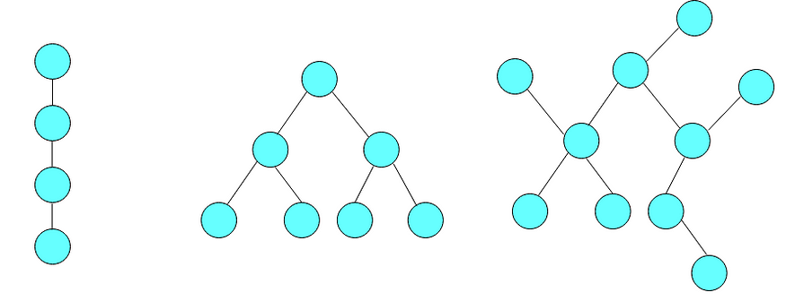
All the graphs given above are trees even the left most one because it has no cycles in it.
- Rooted Tree
A rooted tree is a tree with a designated root node where all other nodes are either coming towards the root or going away from the root.
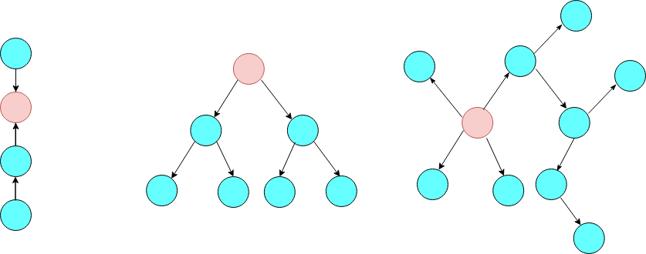
The node which is in red color is the root node. The left most tree is called an In-tree because all other nodes are coming towards the root node. The two other trees are Out-trees, because all other nodes are going away from the root.
- Directed Acyclic Graphs (DAGs)
DAGs are directed graphs with no cycles. These graphs play an important role in representing structures with dependencies such as schedulers and compilers.
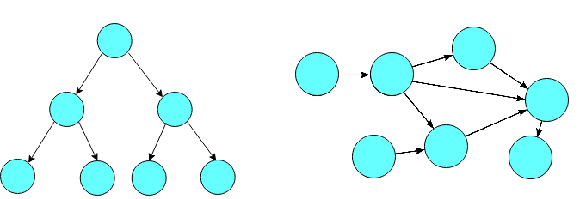
Photo by Author
We can use this graph to show the topological order between something meaningful. For example, if we use DAGs in a process manager, we could say like sub-processes x and y should be completed before proceeding with z.
- Bi-Partite Graphs
A Bi-Partite Graph is a one whose vertices could be divided into two disjoint sets say U and V, where each edge in the graph connects the vertices between U and V. Other similar definition to a Bi-Partite Graph is that the graph would be two colourable.
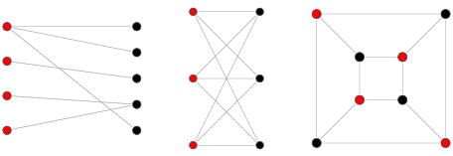
If we look at the graph, we could see like each graph is divisible into two disjoint sets (U, V) and each edge connects the nodes between U and V.
- Complete Graph
We call a graph Complete iff, each pair of vertices has a unique edge connecting between them. A complete graph with n vertices is denoted as Kn.
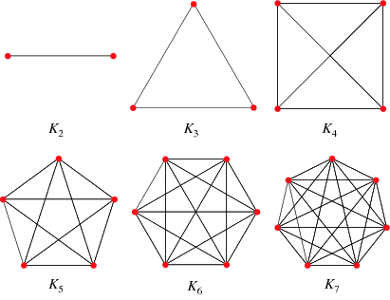
Complete graphs are considered to be the worst case graphs because of the number of edges to be traversed.

Representation of Graphs
Here we discuss how we store a graph in the memory for further processes.
- Adjacency Matrix
The efficient way is to use a matrix of size NxN where N is the number of nodes. We call this matrix an adjacency matrix.
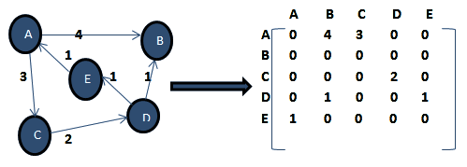
The above given is of a directed weighted graph and it’s corresponding adjacency matrix M. The matrix is of size 5x5 as there are 5 nodes in total. The cost from node A to B is 4 and it’s given in M[A][B]. Similarly, the cost from one node to itself is zero, so all the diagonal elements would always be zeros. This is a space efficient method to store the graph information for the dense structures and the edge look up would always take a constant time. But, as the number of nodes increase, the space required to keep track of the edge information would also increase exponentially. If most of the edges don’t have a proper information, we would endup making a sparse matrix.
- Adjacency Lists
Another important structure we use to store the node and edge information is an adjacency list. This is a map from nodes to lists of edges.
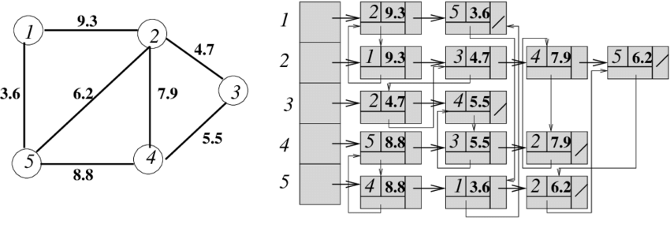
The given example is of an undirected weighted graph. If we look at the rightmost diagram, we could see couple of lists starting from each vertices. Node 1 has two outgoing edges namely 2 and 5, we represent this information along with it’s cost. Each element in the list has the target node and the corresponding cost or weight.
Adjacency List is an efficient mechanism to store the graph information if it is sparse i.e. it would take less memory as compared to the adjacency matrix in the same scenario. But still, this is a slight more complex representation rather than the adjacency matrix.
- Edge Lists
AN edge list is a way to represent a graph simply as an unordered list of edges. Assume the notation for any triplet (u, v, w) means:
“ the cost from u to v is w”.
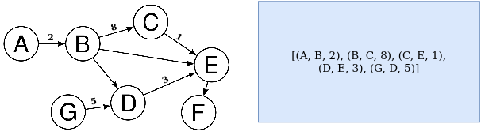
The edge list is given in the right hand side corresponding to the directed weighted graph on the left hand side. Each pair in the list shows edge information between two nodes and associated weight.

